+6

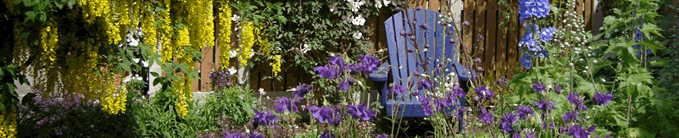
8 Week Mindfulness Based Stress Reduction ( MBSR)
Course Application Form
It is a requirement of the 8 week MBSR course that the facilitator receives some information about each participant. This information will be held in strictest confidence. On receipt of the completed Application Form the facilitator will arrange a time with you to discuss your Application by phone.
Personal Information
Name: Age: Occupation:
Address:
Home Phone: Mobile:
Email address:
Emergency contact : Mobile:
Relationship with emergency contact :
GP Name & Address: Phone :

Relevant Medical History:
High Blood Pressure: Low blood pressure :
Cardiac Conditions :
Diabetes:
Epilepsy:
Any Recent surgery in past year:
Any recent diagnosis in past year:
Injuries to back or neck:
Any history of depression:

Other Information:
Please state briefly why you would like to participate in this course at this particular time in your life?

What are your expectations of the course?

Do you have time in your life at the moment to do the Home Practice of about one hour each day, which is central to this course?

What are the biggest challenges or stresses in your life at present?

How does this challenge or stress present itself on a day to day basis?

Please mention any physical problems or challenges that you may have at the moment, for example, problems with sleep, back pain, headaches:

Please mention any mental or emotional concerns or challenges that you are experiencing at the moment, for example, anxiety, depression, stress, poor concentration, insomnia:

Are you currently attending a psychologist/ psychotherapist or counsellor? If so, are they aware that you are signing up for this 8 week course?
Is your GP aware you are signing up for this 8 week course?
Are you on any prescribed medication? If yes, please give details:

Is there a history of substance abuse? If yes, please give details:

Has there been any significant life changing events in the past year? For example, bereavement, loss, unemployment, diagnosis, surgery, etc

Thank you for taking the time to fill out this Application Form.

Please return this form to info@ashehouse.ie or Anne Kirwan, Ashe House, Corduff, Lusk, County Dublin

